Graph It Design Duration: 4-5 weeks

The “Graph It Design” Project  The goal of the Graph It Design is to have students create a theatrical backdrop during a dialogue between a historical character and Charles Darwin. The students will adapt a primary source (image) pertaining to their chosen character into its basic linear form, which will allow them to determine what characteristics of the image survive.  Scope of Work  Every student is responsible for creating a linear graph on Microsoft Excel pertaining to a historical character.  Deliverables  Original Image  Hand-plotted Image  Connect the Dots  Excel Table & Graph  Toga Night – An Evening With Darwin | 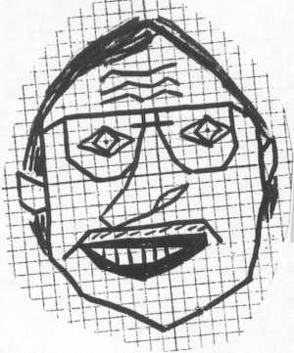  Note: Mr. Aguirre does not qualify as a Historical Character
Requirements
The Original Image must:
-- Be an approved primary source (image)
-- Be maximized on an 8.5" by 11" piece of paper
The Hand-plotted Image must:
-- Have a washed out version of the Original Image printed on graph paper
-- Have a detailed grid with X- & Y-axis
-- Have defined points with connecting lines
-- Have at least 124 lines
-- Have the X- & Y-axis centered on the image
-- Have a combination of horizontal, vertical, positive/negative sloped lines
-- Exceeding Expectations: Have a few shaded areas with the use of inequalities
Connect the Dots must be completed before moving onto the Excel Graph.
The Excel Table & Graph must:
-- Show all the fixed (x) and generated (y) values of the points on the table
-- Have all the points and lines on the graph
-- Have the Table and Graph on separate tabs
-- Be titled, labeled, and stylized using available tools
-- Exceeding Expectations: Using the table calculate the total length of ALL the lines
The Excel Graph must be presented during Toga Night - An Evening With Darwin.
Grading Criteria
The varying weights for the following criteria will determine their overall score.
-- Thoughtfulness & Thoroughness
-- Work Ethic & Behavior
-- Deadlines & Deliverables
-- Exceeding Expectations

